

**Automation**

**Report**

**Summary** :

Total : 12

Passed : 6

Failed : 4

Skipped : 2

516c9b17-6a1b-4266-8281-668a88e4dc8c.png

**Test ID** : #**2**

**Executed At** : 07/07/2025, 09:35:20.

**Executed Time** : 1.88m

**Environment** : TestInternal, TestInternal1, TestInternal4

**App** : SMARTGOV

|  |  |  |  |
| --- | --- | --- | --- |
| Total | Passed | Failed | Skipped |
| 6 | 3 | 2 | 1 |

**Detail**

**Row 1 | TestInternal**

**1** **–** **Login [FAILED]**

**Error** : Pengguna tidak ditemukan atau Kata sandi salah

**Duration** : 7.83s

**Screenshot** :

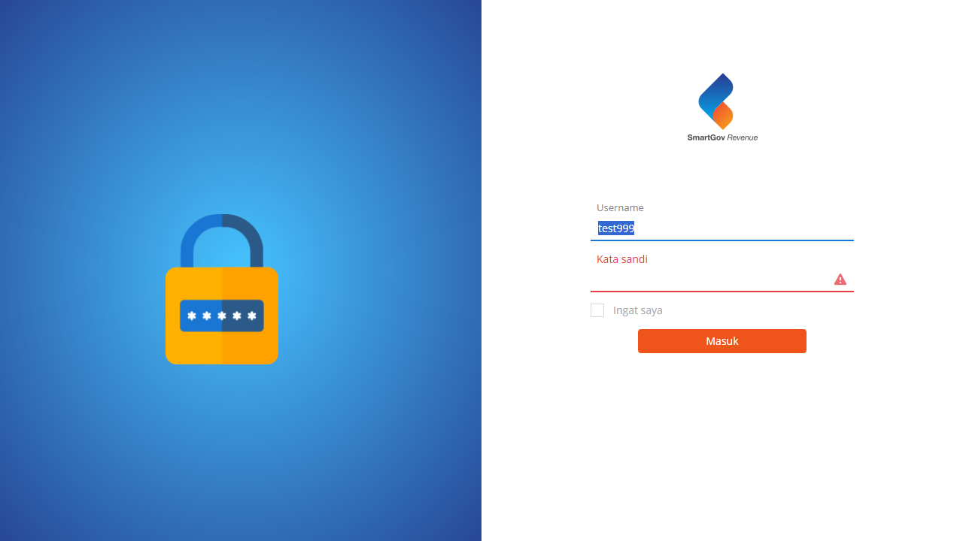

**200** **–** **Rekam Pelayanan Tunggal [SKIPPED]**

**Error** : Skipped due to previous case failure

**Duration** : 0s

**Screenshot** :

-

**Row 2 | TestInternal1**

**1** **–** **Login [PASSED]**

**Error** : -

**Duration** : 6.55s

**Screenshot** :



**200** **–** **Rekam Pelayanan Tunggal [FAILED]**

**Error** : Data Objek Pajak atas NOP yang dimasukkan sudah ada dalam basis data!

**Duration** : 58.39s

**Screenshot** :

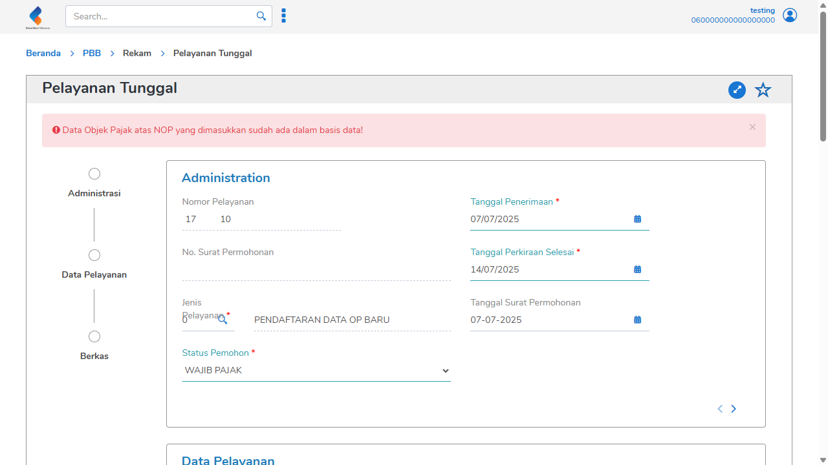

**Row 3 | TestInternal4**

**1** **–** **Login [PASSED]**

**Error** : -

**Duration** : 5.63s

**Screenshot** :



**200** **–** **Rekam Pelayanan Tunggal [PASSED]**

**Error** : -

**Duration** : 55.05s

**Screenshot** :

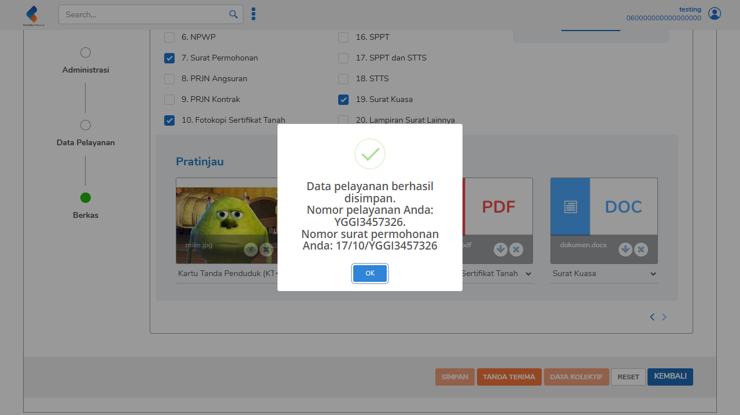

---------------------

**Test ID** : #**3**

**Executed At** : 08/07/2025, 11:15:55.

**Executed Time** : 1.74m

**Environment** : TestInternal, TestInternal1, TestInternal4

**App** : SMARTGOV

|  |  |  |  |
| --- | --- | --- | --- |
| Total | Passed | Failed | Skipped |
| 6 | 3 | 2 | 1 |

**Detail**

**Row 1 | TestInternal**

**1** **–** **Login [FAILED]**

**Error** : Pengguna tidak ditemukan atau Kata sandi salah

**Duration** : 4.27s

**Screenshot** :



**200** **–** **Rekam Pelayanan Tunggal [SKIPPED]**

**Error** : Skipped due to previous case failure

**Duration** : 0s

**Screenshot** :

-

**Row 2 | TestInternal1**

**1** **–** **Login [PASSED]**

**Error** : -

**Duration** : 4.32s

**Screenshot** :



**200** **–** **Rekam Pelayanan Tunggal [FAILED]**

**Error** : Data Objek Pajak atas NOP yang dimasukkan sudah ada dalam basis data!

**Duration** : 48.89s

**Screenshot** :

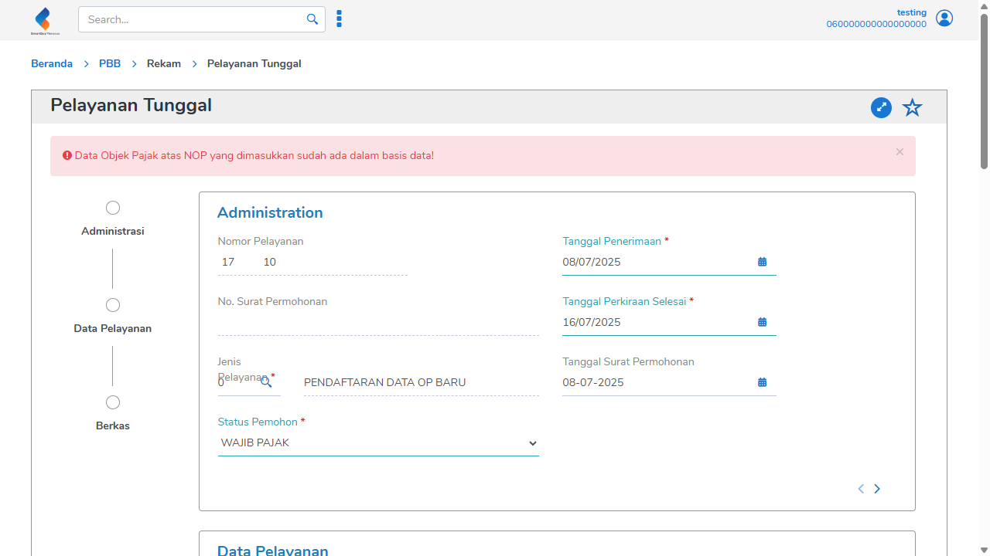

**Row 3 | TestInternal4**

**1** **–** **Login [PASSED]**

**Error** : -

**Duration** : 3.95s

**Screenshot** :



**200** **–** **Rekam Pelayanan Tunggal [PASSED]**

**Error** : -

**Duration** : 55.74s

**Screenshot** :



